**Introduction to Pointers in C++**

Pointers are symbolic representations of addresses. They enable programs to simulate call-by-reference as well as to create and manipulate dynamic data structures. Iterating over elements in arrays or other data structures is one of the main use of pointers.

The address of the variable you’re working with is assigned to the pointer variable that points to the same data type (such as an int or string).

**Syntax:**

datatype *var_name;

int *ptr; // ptr can point to an address which holds int data

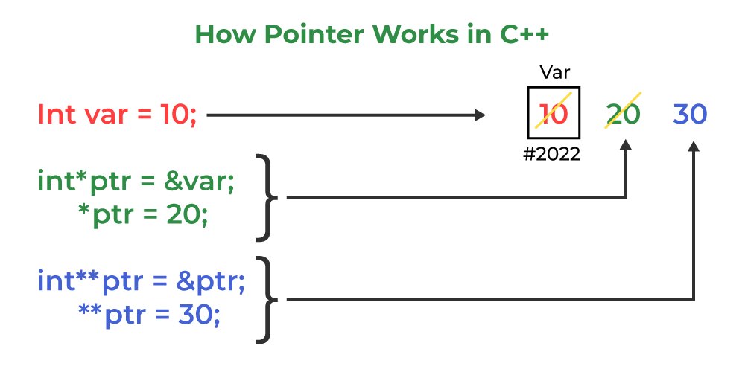

**How to use a pointer?**

* Define a pointer variable
* Assigning the address of a variable to a pointer using the unary operator (&) which returns the address of that variable.
* Accessing the value stored in the address using unary operator (*) which returns the value of the variable located at the address specified by its operand.

The reason we associate data type with a pointer is **that it knows how many bytes the data is stored in**. When we increment a pointer, we increase the pointer by the size of the data type to which it points.

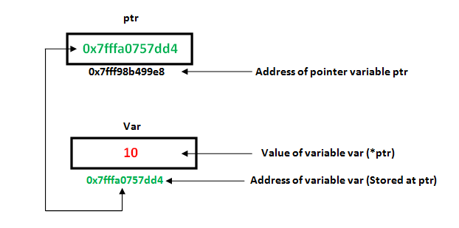 C++

// C++ program to illustrate Pointers

#include <bits/stdc++.h>

using namespace std;

void geeks()

{

int var = 20;

// declare pointer variable

int* ptr;

// note that data type of ptr and var must be same

ptr = &var;

// assign the address of a variable to a pointer

cout << "Value at ptr = " << ptr << "\n";

cout << "Value at var = " << var << "\n";

cout << "Value at *ptr = " << *ptr << "\n";

}

// Driver program

int main()

{

geeks();

return 0;

}

**Output**

Value at ptr = 0x7fff9a230c0c

Value at var = 20

Value at *ptr = 20